**Abstract**

This abstract provides an overview of a solar design and installation project aimed at promoting sustainable energy generation. The project focuses on the design and installation of a solar photovoltaic (PV) system to harness solar energy and convert it into electricity. By implementing this renewable energy solution, the project aims to reduce reliance on traditional fossil fuel-based energy sources and mitigate the environmental impact associated with greenhouse gas emissions.

The project begins with a comprehensive site analysis to determine the optimal location and orientation of the solar PV system. Factors such as solar radiation, shading, and available space are considered during this phase. Using advanced software tools, the project team develops detailed engineering designs, including the selection of appropriate PV modules, inverters, mounting structures, and balance-of-system components.

Once the design phase is complete, the project moves to the installation stage. Highly skilled and experienced technicians are employed to ensure the proper installation and connection of the solar panels, inverters, and other components. Strict adherence to safety guidelines and local regulations is followed throughout the installation process.

To maximize energy generation and system efficiency, the project integrates advanced monitoring and control systems. These systems enable real-time performance monitoring, fault detection, and maintenance scheduling, ensuring the optimal operation of the solar PV system.

The economic viability of the project is also considered. A thorough financial analysis is conducted, taking into account factors such as the initial investment cost, operational expenses, and potential savings in energy bills over the system's lifespan. Additionally, available incentives, such as government rebates and tax credits, are explored to enhance the project's financial attractiveness.

Furthermore, the project includes an educational component to raise awareness about the benefits of solar energy and sustainable practices. Public outreach programs, workshops, and educational materials are developed to engage and inform the community, encouraging wider adoption of renewable energy technologies.

In conclusion, the solar design and installation project aims to contribute to the transition towards a greener and more sustainable future. By harnessing the power of solar energy, the project strives to reduce carbon emissions, increase energy independence, and promote environmental stewardship within the community.

**CHAPTER ONE**

**INTRODUCTION**

**1.1 Background of study**

Solar panel design and installation involve the process of harnessing energy from the sun to generate electricity. Solar panels, also known as photovoltaic (PV) panels, are devices that convert sunlight into usable electrical energy. They are an essential component of solar power systems and are widely used for both residential and commercial applications.

The design and installation of solar panels require careful consideration of various factors, including the location, orientation, efficiency, and electrical requirements of the system. Here is an overview of the key aspects involved in solar panel design and installation:

1. Site Assessment: The first step is to evaluate the site's solar potential. Factors such as sunlight availability, shading from nearby objects (e.g., trees or buildings), and the orientation and tilt of the roof or ground determine the system's performance. An unobstructed area with maximum sunlight exposure is ideal for solar panel installation.
2. System Sizing: Based on the energy needs of the property, the solar system must be appropriately sized. Factors such as electricity consumption, available roof space, and the amount of sunlight in the region help determine the number and size of solar panels required to meet the desired energy output.
3. Panel Selection: Solar panels come in various types, such as monocrystalline, polycrystalline, and thin-film panels, each with different efficiencies and costs. The selection of panels depends on factors like budget, available space, and desired system performance.
4. Mounting and Racking: Once the panels are chosen, they need to be securely mounted on rooftops or ground-mounted frames. Mounting systems ensure proper orientation, tilt, and structural stability to maximize energy production and withstand weather conditions.
5. Electrical Wiring: Proper electrical wiring is crucial to connect the solar panels and other components of the system. This includes wiring panels in series or parallel to achieve the desired voltage and current levels, as well as installing safety measures like fuses and disconnect switches.

**1.2 Aim:**

The aim of the solar installation project report is to assess the feasibility, implementation, and impact of a solar energy system installation.

**1.2.1 Objectives:**

1. Feasibility Assessment: Evaluate the technical, economic, and environmental feasibility of installing a solar energy system in a specific location or facility. This includes analyzing the solar resource availability, assessing the site conditions, and determining the viability of the project.
2. System Design and Implementation: Develop a detailed solar energy system design and provide specifications for the equipment, such as solar panels, inverters, batteries, and monitoring systems. Determine the optimal system size and configuration based on energy demand and available space. Outline the installation process, including any necessary permits and approvals.
3. Cost Analysis: Conduct a comprehensive cost analysis of the solar installation project. This includes estimating the initial investment, including equipment, installation, and connection costs. Assess the potential savings and payback period through reduced electricity bills and potential revenue from excess power generation.
4. Environmental Impact Assessment: Evaluate the environmental benefits of the solar installation project, including the reduction of greenhouse gas emissions, air pollution, and reliance on fossil fuels. Consider the project's contribution to sustainability and the potential for carbon footprint reduction.
5. Inverter Installation: Solar panels generate direct current (DC) electricity, while most household appliances and the electrical grid operate on alternating current (AC). An inverter is installed to convert DC electricity from the panels into usable AC electricity.

**1.3 Scope and Limitation**

Scope:

1. Site Assessment: The scope of solar installation and design includes conducting a thorough site assessment to determine the feasibility of installing solar panels. This involves analyzing factors such as solar resource availability, shading analysis, roof orientation, and structural integrity.
2. System Design: The scope includes designing the solar energy system based on the energy needs of the site. This involves selecting the appropriate type and size of solar panels, inverters, batteries (if applicable), and other components. The design should also consider electrical wiring, grounding, and protection measures.
3. Energy Generation Analysis: The scope includes estimating the expected energy generation of the solar system based on site-specific data and system design. This analysis helps in determining the system's capacity to meet the energy demands and potential savings on electricity bills.
4. Economic Analysis: The scope includes conducting a financial analysis to assess the economic viability of the solar installation. This involves estimating the initial investment, calculating the payback period, analyzing return on investment (ROI), and considering factors such as government incentives, tax benefits, and financing options.
5. Environmental Impact: The scope includes evaluating the environmental benefits of the solar installation. This involves analyzing the reduction in greenhouse gas emissions, air pollution, and dependence on fossil fuels. It also considers the potential for sustainability and the project's contribution to carbon footprint reduction.

**Limitations:**

1. Cost Considerations: The installation and design of a solar energy system can involve significant upfront costs, which may limit the feasibility for some projects. Financial constraints and budget limitations may impact the scope and scale of the installation.
2. Space Limitations: The availability of sufficient space for solar panel installation can be a limitation. In cases where the site has limited roof area or shading issues, the system's capacity may be constrained, affecting energy generation potential.
3. Site Suitability: The effectiveness of solar installation is dependent on the site's characteristics, such as solar resource availability and roof orientation. Sites with low solar irradiance or unsuitable roof angles may have limited solar energy generation potential.
4. Technical Constraints: The scope of solar installation and design can be limited by technical factors such as grid connectivity, electrical infrastructure, and interconnection regulations. Existing electrical systems may require upgrades or modifications to accommodate the solar energy system.
5. Maintenance and Operation: Solar installations require regular maintenance and monitoring to ensure optimal performance. The scope of the project may be limited by the availability of skilled personnel and the cost of ongoing maintenance.

**1.4 Contribution to knowledge**

The contribution to knowledge of solar installation and design lies in the advancements and insights gained through research, practical implementation, and continuous improvement in this field. Here are some key contributions:

1. Technical Innovations: Solar installation and design contribute to expanding the knowledge base by driving technical innovations. Researchers, engineers, and industry professionals continuously explore new materials, designs, and technologies to enhance solar panel efficiency, durability, and ease of installation. These innovations contribute to increased energy generation and improved system performance.
2. System Optimization: Solar installation and design studies contribute to knowledge by developing techniques and methodologies to optimize system performance. This includes improving the design and placement of solar panels, considering factors such as shading analysis, tilt angles, and tracking systems. Optimization efforts aim to maximize energy production, increase system reliability, and reduce costs.
3. Integration with Building and Infrastructure: Solar installation and design research has contributed to the knowledge of integrating solar energy systems with buildings and infrastructure. This includes architectural integration of solar panels into building designs, development of solar-powered smart grids, and integration with energy storage systems. These advancements help promote sustainable and efficient energy use in various sectors.
4. Performance Modeling and Simulation: Contributions to knowledge in solar installation and design involve the development of performance modeling and simulation tools. These tools enable accurate prediction and evaluation of energy generation, system performance, and financial feasibility. Researchers and industry professionals use these models to optimize system designs, assess different scenarios, and make informed decisions.
5. Policy and Regulatory Insights: Solar installation and design studies contribute to knowledge by providing insights into policy and regulatory frameworks. Research on the impact of incentives, subsidies, and regulations helps policymakers and industry stakeholders develop effective strategies for promoting solar energy adoption, grid integration, and the establishment of supportive market environments.
6. Environmental and Social Impacts: Solar installation and design research contributes to understanding the environmental and social impacts of solar energy systems. Studies investigate the life cycle assessment of solar panels, their carbon footprint, and the potential for reducing greenhouse gas emissions. Additionally, research explores the socioeconomic benefits, job creation potential, and community engagement associated with solar installations.
7. Case Studies and Best Practices: Knowledge is advanced through case studies and the sharing of best practices in solar installation and design. Real-world projects provide valuable insights into successful implementation strategies, challenges encountered, and lessons learned. This knowledge exchange helps professionals in the field to make informed decisions, avoid common pitfalls, and achieve optimal outcomes.

**1.5 Areas of Application**

Solar panel installations have a wide range of applications across various sectors. Here are some common areas where solar panels are installed:

1. Residential Buildings: Solar panels are commonly installed on residential rooftops to generate electricity for individual households. Homeowners can reduce their dependence on the grid and save on electricity bills by utilizing solar power.
2. Commercial Buildings: Solar panels are also installed on commercial buildings, including offices, retail stores, warehouses, and factories. These installations help businesses reduce their operational costs, meet sustainability goals, and demonstrate environmental responsibility.
3. Industrial Applications: Solar panels can be used in various industrial applications, such as powering machinery, lighting systems, and other electrical equipment in manufacturing plants, industrial complexes, and mining operations.
4. Agricultural Sector: Solar panels can be installed in the agricultural sector for powering irrigation systems, water pumps, and farm equipment. Solar-powered irrigation can be particularly beneficial in remote areas where grid electricity is limited.
5. Educational Institutions: Schools, colleges, and universities often install solar panels to generate electricity and promote renewable energy education. Solar installations can also serve as teaching tools for students to learn about sustainable energy sources.
6. Government and Public Buildings: Solar panels are commonly installed on government buildings, hospitals, community centers, and other public facilities. Governments at various levels often encourage the adoption of solar energy through incentives and initiatives.
7. Remote Areas and Off-Grid Systems: Solar panels are valuable in remote areas and regions where access to electricity from the grid is limited. They can power off-grid systems, including remote communities, cabins, telecommunication towers, and weather stations.
8. Transportation: Solar panels can be integrated into various modes of transportation, such as electric vehicles (EVs), buses, boats, and bicycles. Solar charging stations can also be set up to facilitate the charging of EVs using solar power.
9. Emergency and Disaster Response: Solar panels are used in emergency and disaster response situations to provide immediate access to electricity. Portable solar panels and solar-powered generators can help supply power for lighting, communication, and medical equipment.

10.Large-Scale Solar Farms: Solar panels are deployed in large-scale solar farms or utility-scale installations, where vast areas of land are dedicated to solar energy generation. These solar farms feed electricity into the grid to meet the demand of a wide range of consumers.

**CHAPTER TWO**

**LITERATURE REVIEW**

**2.1. Review of past related work.**

**Premila T. R. 2022**

His work proposes a solar PV powered single switch buck-boost converter which reduces implementation cost, minimal voltage and current stress across the capacitors and diodes and less switching power losses. The work structure comprises of solar PV source with modified P and O algorithm based MPPT, single switch buck-boost dc-dc converter, battery backup to store excess energy, three phase inverter with sinusoidal PWM to find optimal switching angles for harmonic control and 3Φ induction motor load. Here reduction of THD is applied to the line to line voltage of the inverter. Performance analysis of the proposed circuit is done using MATLAB/SIMULINK platform. A detailed steady state analysis of the dc-dc converter topology is also analyzed to system stability. The proposed single switch buck-boost converter is designed to provide an output voltage and current of 363V, 45.5A DC from 520V, 35A PV array. The designed converter is then employed to run a three phase full bridge inverter with 440V, 15A AC. From the simulation results, it is found that the solar powered single switch buck-boost with MPPT is stable, efficient with minimal losses and less THD with better quality output.

**Ayaz A. Khamisani 2017** his Researchers suggest that the amount of sunlight that strikes the Earth's surface in an hour and a half is enough to handle the entire world's energy consumption for a full year. Solar power system is one of the best renewable energy technology which is not only cost effective but environment friendly as well. From his research, he suggested methodologies that may be applicable to other off grid applications. He explained design methodology using an example of an off-grid bus shelter. Off-grid or standalone systems can be defined as independent systems that are not connected to any electrical grid. These come in different sizes and are mostly used in location where there is little access to grid infrastructure.

**Mustafa Aslan 2015** In his study, a new approach was suggested in the selection of material to be used in solar panel systems in country cottages. In the suggested approach, the panels are connected in two different groups taking into consideration the hours of usage of the loads that will consume the electricity. One of these groups is used to meet instant needs whereas the other is used to charge the battery. In this way, fewer solar panels are needed compared with the conventional calculation method. Moreover, the number of batteries needed by the system is also reduced. As a result, the number of solar panels and battery-related costs can be reduced.

**Atsushi SHIOTA 2019** The main idea for his research was that using high resolution can more accurately check the proper solar panels' installation location and the best direction and angle of the solar panels by using GIS program functions. The eventual aim is to create and develop a realistic distribution system model before installing the rooftop solar photovoltaic in the residential area. This model can be adjusted according to the existing residential area or a residential planning area wherever in this world to use the model for distribution system planning.

**[Samuel Shaka](https://www.researchgate.net/profile/Samuel-Shaka) 2022**

This paper presents the design and construction of 5kva solar power inverter system. The solar panelswere installed free from trees/building shade and aligned to receive maximum sun rays at 45 0 NorthEast. The panels were then connected to the charge controller and the circuit was wired to the battery.It was observed that 7.8 % of the total output power was lost during the testing and measurements which resulted from components used. The output voltage (V OUT) for both expected and achieved values of the solar cell is 100V, the output current (I OUTPUT) for the inverter is 10A for expected value and 9.7A for the achieved value. The inverter wasusedextensively with different appliances of diverse power or wattage. However, care was taken not to overloadtheinverterbeyond its maximum power rating of 5kva.Based on testing and measurements during operation, the inverter has relatively small output resistance and low power consumption for its circuitries while delivering optimal output power depending on the wattage of the load

**2.2 Block Diagram.**

PV Solar

Panels

DC-DC

Converter

(Charge Controller)

DC Surge

Storage Device

(Batteries)

**Fig 2.1:Block diagram of solar system**

* **PV Solar Panels**

A solar cell or photovoltaic cell can be defined as a device that converts light directly into electricity by the photovoltaic effect. Solar Photovoltaic systems generate electricity directly using sunlight.

* **DC Surge**

A DC surge device, also known as a DC surge protector or DC surge suppressor, is a protective device designed to mitigate the effects of DC surges on electrical and electronic systems. These devices are similar to surge protectors used for AC systems but are specifically engineered to handle DC power.

* **DC-DC Converter(Charge Controller)**

Charge controllers, also known as charge regulators or battery regulators, are electronic devices used in renewable energy systems to regulate the charging process of batteries. They are commonly used in solar power systems, wind power systems, and other off-grid or hybrid systems.

* **Storage Device**

Batteries are electrochemical devices that store and provide electrical energy. They are widely used to power various devices, ranging from small electronics like smartphones and laptops to larger systems such as electric vehicles and backup power systems. Batteries are portable, rechargeable, and provide a convenient source of energy.

**2.3 Components Review of Solar Installation**

Solar design and installation is absolute easy thing one can do but with proper knowledge, training and skill with some money to purchase the equipments. Some of the components you need for installation of solar energy are listed below:

* Solar system
* Solar panels (photovoltaic PV modules) ▪
* Charge controller ▪
* Battery ▪
* Inverter ▪
* connecting wires ▪
* Appliances (like Bulb, TV, Fan etc)

**2.3.1 The Solar system**

Solar System can be defined as the Sun and everything that orbits the Sun which also include the planets and their satellites. It can also be called a group of celestial bodies orbiting another star. In this paper, solar system refers to the system that includes Earth and the Sun. Solar energy is the energy from the sun. It comes to us in form of light and heat. Nigeria receives about 4.851 X 10P 12P KWh of energy from sun daily, 1.804 X 10P 15 PKWh annually and the country has average solarP Pinsolation of about 5.535KWh/mP 2 P/day which will effectively be used for solar power installation, and will bring about total change in power system failure in the country.

**2.3.2 Solar panels (photovoltaic PV modules)**

A solar cell or photovoltaic cell can be defined as a device that converts light directly into electricity by the photovoltaic effect. Solar Photovoltaic systems generate electricity directly using sunlight. Solar thermal systems actively or passively collect, transport, and utilize solar energy to generate heat. The generation of voltage across the p-n junction in a semiconductor due to the absorption of light radiation is called photovoltaic effect. The Devices based on this effect is called photovoltaic device. The solar panel converts the solar energy (energy from the sun) to electricity which charges the battery. For more effective use, more than one solar panel are electrically connected to form array for the purpose of collecting a good amount of sun to charge the battery which will be capable of supplying a home the amount of electricity needed. Solar panel connections are done in two different ways for efficient useful work.

The two ways of connecting solar PV are as follows:

* Series connections. ▪
* Parallel connections.

**2.3.2.1 Series connection**

In a series connection, the positive terminal of one solar panel is connected to the negative terminal of the next panel, forming a series string. This configuration increases the voltage output while keeping the current constant. The total voltage of the series-connected panels adds up, resulting in higher voltage output. Series connections are commonly used in grid-tied systems where higher voltages are required to match the utility grid voltage.

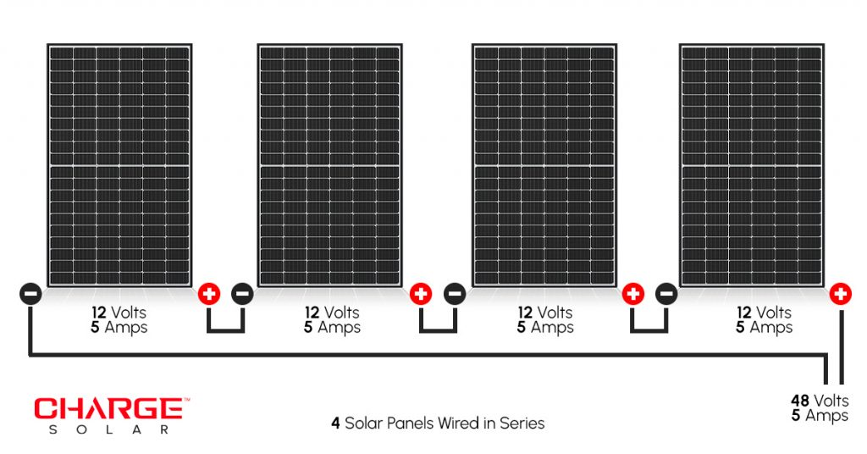

**Fig 2a: Series connection of solar module**

**2.3.2.2 Parallel connection**

In a parallel connection, the positive terminals of all the solar panels are connected together, and the negative terminals are also connected together. This configuration keeps the voltage constant while increasing the total current output. Parallel connections are often used when there is a need for higher current output but with a consistent voltage. They are commonly found in off-grid systems or when connecting multiple solar panels to charge batteries.

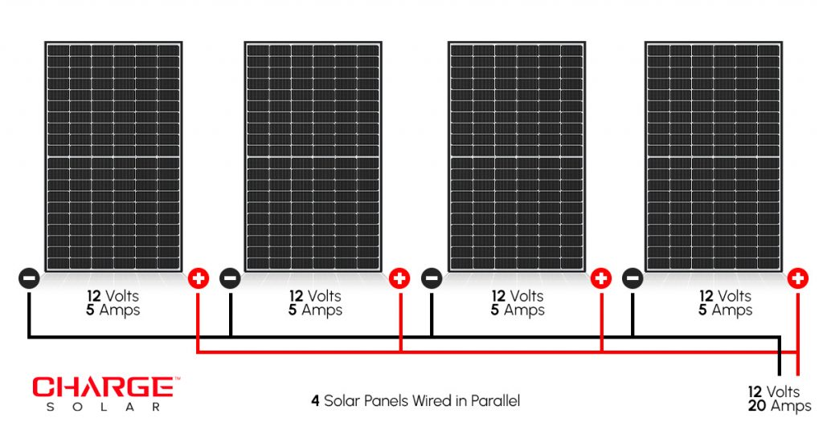

**Fig 2b: Parallel connection of solar module**

**2.3.2.3 Series-Parallel Connection (Combination Wiring):**

A series-parallel connection combines both series and parallel connections to achieve a desired balance of voltage and current. In this configuration, solar panels are first connected in series to increase the voltage, and then multiple series strings are connected in parallel to increase the current output. This configuration allows for achieving both higher voltage and higher current requirements, making it suitable for larger solar installations that require a specific voltage and current capacity.

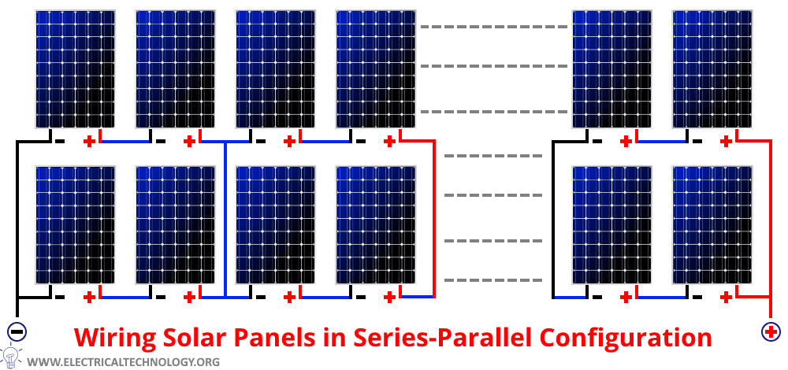

**Fig 3a: Series-parallel connection of solar module**

**2.3.3 Charge Controller**

▪Charge controllers, also known as charge regulators or battery regulators, are electronic devices used in renewable energy systems to regulate the charging process of batteries. They are commonly used in solar power systems, wind power systems, and other off-grid or hybrid systems.

The primary function of a charge controller is to manage and control the flow of electrical energy from the power source (such as solar panels or wind turbines) to the batteries. Here are some key features and functions of charge controllers:

1. Battery Protection: Charge controllers protect the batteries from overcharging by monitoring the battery voltage and limiting the charging current when the batteries are fully charged. This helps prevent damage to the batteries, such as excessive gassing or electrolyte loss.
2. Charging Modes: Charge controllers often have different charging modes, such as bulk charging, absorption charging, and float charging. These modes ensure that the batteries are charged efficiently and safely, following specific charging profiles suitable for the battery type.
3. Load Control: Some charge controllers feature load control capabilities, allowing them to directly manage and supply power to DC loads. This feature can be useful for powering devices or loads connected directly to the charge controller, independent of the battery bank.
4. Monitoring and Data Display: Many charge controllers provide monitoring features, displaying real-time information such as battery voltage, charging current, state of charge, and other relevant data. This allows users to keep track of the system's performance and battery status.
5. System Protection: Charge controllers offer protection features like overvoltage protection, reverse polarity protection, short-circuit protection, and overcurrent protection. These safeguards help protect the system components from potential damage due to electrical faults or incorrect wiring.

Charge controllers are available in various types and sizes to accommodate different system configurations and battery capacities. The selection of a suitable charge controller depends on factors such as the power source, battery voltage, system capacity, and specific requirements of the renewable energy system.

It's worth noting that charge controllers are primarily used in off-grid or hybrid systems where battery storage is involved. Grid-tied solar systems, which directly feed excess power into the grid, typically do not require charge controllers as the grid acts as the storage and regulates the power flow.



**Fig 2d: MPPT Charge Controller**

**2.3.4 Battery**

Battery stores the electrical charge produced by the solar panel during the day. It helps the output of the solar panel when it cannot supply enough electricity to the system. Batteries are a major cost of any solar system and are the most friable component in the solar system. Battery should have sufficient Amp hour storage to supply the needed power during the cloudy weather. Batteries can be either shallow cycle discharge (for automobiles) or deep cycle discharge (for PV system). A shallow-cycle batteries discharge only between 10% and 20% of their Ah capacity/day discharging beyond this point without recharging shortens the battery life. Deep-cycle batteries are designed to allow a discharge of 60% to 80% of its Ah capacity. A battery discharged at a rate of 1 amp will have a higher Ah capacity than a battery discharged at a rate of 4 amps. A battery which can deliver 1 amp for 100 hours has a capacity of 100Ah @ C100. The same battery may only deliver 4 amps for 20 hours. Then its capacity is 80Ah @ C20. C100 means discharged over 100 hours, C20 means discharged over 20 hours. Batteries are connected in series and parallel.

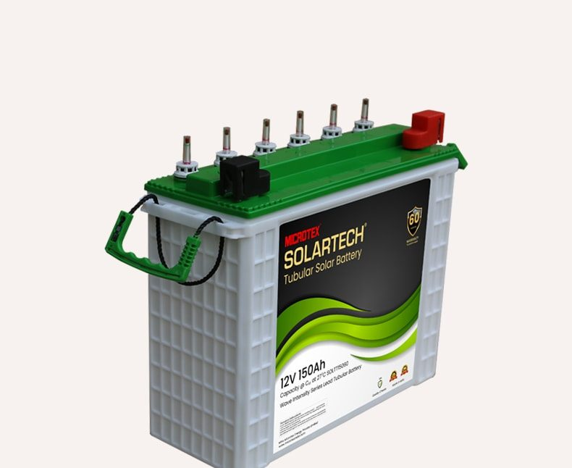

**Fig 2e: Deep Cycle Battery**

**2.3.5 Inverter**

This is what will turn the 12 volt DC current into 110-120 volts AC current for use in powering your household electrical devices. An inverter is device that changes direct current (DC) from the battery to alternating current (AC) to be used for AC appliances. The battery provides DC voltage to the inverter, and the inverter converts the DC voltage to normal AC voltage. The output of a solar PV system can be either DC or AC depending on the type of electrical load it is meant to power. If it is used to power a DC load, then there is no need for an inverter. However inverter is required when the electrical load is AC. One can choose to go for solar inverter; solar inverters have some special functions with the photovoltaic arrays like maximum power point tracking and anti-islanding protection. There are two types of inverters which include modified sine wave and pure sine wave inverters. Note: the size of the inverter should be around three times what you plan to use it for, this is because the consumer products do not always use the best components and this is a way to ensure your unit will last longer than when you purchase an undervalued unit and push it to burn out. Before you buy an inverter you need to take cognizes of the following:

1. The maximum load; the rating is larger than wattage of all the ac loads to be run at any one time
2. The maximum surge; Inverter is designed to surge if motors will be connected.
3. The output voltage

iv. The input battery voltag

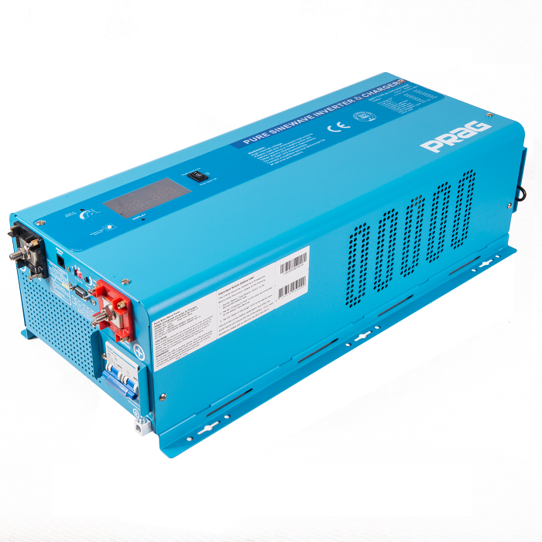

**Fig 2f: Pure Sine wave inverter**

**CHAPTER THREE**

**DESIGN AND ANALYSIS**

**3.1 DESIGN SPECIFIFCTIONS**

The design of this solar panel system has the following components:

1. The photo votaic cell unit.
2. The controller unit.
3. The Protection unit.
4. The storage unit.

**3.2 DESIGN CONSIDERATION OF EACH COMPONENT**

Considering the vast range of components available in the market with varying specifications. It has become of extreme importance we pay keen attention to ensure that components selection is done with not just safety and power requirements but also its compatibility with every other component we shall be using. With that in mind and with the knowledge of our desired output which is 24v DC, we shall move ahead to detail the steps taken in the selection of our various components.

**3.3 TOTAL CURRENT REQUIREMENT**

It is of great importance that we make the selection of our components with keen attention to their power requirements. We shall have to understand the individual current requirement for the components and this shall be applied to determine our overall current requirement. Having this knowledge will be very helpful also in the selection of our controller unit.

The proposed system is rated 5KVA which needs backup from the solar panels

The total power in watts will be P = IVCos Q

P = power in watts

Q = power factor of the system

P = 5000 x 0. 8 = 4000Watts

P = 4Kwatts

study shows that panels are mostly 330watts to 450watts @24volts

and 330watts panels are most common to see

dividing the proposed power by the power of one panel to get the number of panels needed at the input of the system

No. Panels = 4000Watts/330watts = 12panels (aproximately).

**3.4 THE CHARGE CONTROLLER UNIT**

Since the number of panels have been determined from the calculation and the recommeded power is 4000watts

The charge controller to be used current capacity can be calculated

using P = IV

P = Power demanded (4000watts)

V = Voltage of the system(24volts)

I = current demanded

I = P/V =4000/24 = 167Amps (approximately).

Hence a 2 100Amps MPPT charge controller connected in parallel will be used.

**3.4 THE PROTECTION UNIT**

This unit consist of protection devices such DC surge , circuit breaker(DC)

the current rating of the breaker will be 180Amps max so as to protect the charge controllers from being over loaded

while the DC surges are rated in voltage which helps to sink high voltage from thunder storm

DC surge used is rated 500volts Max

**3.5 THE STORAGE UNIT**

The storage unit consist of the battery bank ,which is determined by

P = IV

I = 5000VA/24 = 208Amps (approximately)

hence we need a two 12volts 220AH battery for a start

**CHAPTER FOUR**

**CONSTRUCTION , MATERIALS ,RESULTS AND DISCUSSION**

**4.0 CONSTRUCTION**

In this chapter, we shall be treating the construction of this project work. We shall be covering the details involved in the design of the micro-grid starting from the measurements to the commissioning of the solar micro-grid. Alongside this, we shall also be treating the precautions taken in the construction of the Micro-grid.

**4.1.1 Componenrs and their Specification**

|  |  |  |  |  |  |  |
| --- | --- | --- | --- | --- | --- | --- |
| **S/N** | **Component** | **Voltage** | **Current** | **Power** | **Qty** |  |
| 1 | Solar Panel | 24volts | 6Amps | 330watts | 12 |  |
| 2 | MPPT Charge Controller | 12/24/48 | 100Amps | 4800watts | 2 |  |
| 3 | DC Breaker | 500v | 200Amps | 100KVA | 1 |  |
| 4 | DC Surge | 500v | 1000Amps | 100KVA | 1 |  |

**4.1.2 MATERIALS, TOOLS AND EQUIPMENTS USED**

Here we shall be listing the various tools and equipment which shall be used in this project work design.

**MATERIALS**

i. Breaker Box

ii. Charge Controller

iii. Solar Cabel 6mm twin

iv. Casing

v. Dc breaker

**TOOLS**

i. Drilling machine

ii. Handsaw

iii. Tape

iv.Screw Driver

**4.4 Findings**

The effectiveness of this experiment depends largely on the similarity and sameness of the load, battery, solar panels and other apparatus of this experiment. It also depends on having both the baseline model and the developed model under the same climatic condition. Haven placed both models under similar conditions, the following findings were reached.

1. The developed operation strategy of the micro-grid gives a power supply reliability improvement of 6.5% compared to the conventional technique. This improvement can reduce the dependence on fossil fuel as an alternative source of power; hence, could make the environment more eco-friendly and conducive.
2. The developed operation strategy of the micro-grid gives a grid power saving of 66.7% compared to the conventional technique. The energy savings translates into high monetary benefits, especially with the high cost of utility grid supply in Nigeria.

3.There was a slight variation of 0.02 A between the battery current and solar panel current for both the developed operation strategy and the traditional technique. This variation can be accounted for by losses in the connecting cables.

**4.5 Contribution to knowledge**

This study has contributed to knowledge in the following ways:

1 a cost-effective operation strategy for grid connected micro-grids has been designed;

2 a more reliable micro-grid system for regions with unreliable grid networks has been developed; and

3 real-time energy profiles of a grid-connected micro-grid has been deduced for Benin City, Nigeria.

**CHAPTER FIVE**

**CONCLUSION AND RECOMMENDATION**

**5.1 CONCLUTION**

To ensure the sustainability of electric power, the micro-grid is used to integrate energy sources in an effective way following a functional operation strategy. The traditional (baseline) operations strategy recognises grid power as the primary power supply source. Hence, it takes precedence when available. With the rising cost of grid power supply, the need to develop a more reliable and cost effective operations strategy arose. The operations strategy guides the energy flow, reduces monetary cost of the power system and ensures maximal utilisation of both the micro-grid components and power sources. In addition, the operation strategy monitors the battery voltage and decides which of the power sources can power the load. This essentially can ensure energy sustainability and reduce cost.

In this study, a micro-grid made up of the PV/battery source was designed and fabricated. The system design was realised through the use of discrete electronics components. Upon testing, the device performed in line with the expected results.

It was found at that the developed strategy reduces the grid power consumption by 66.7% with an improved power supply reliability of 6.5% over the conventional (baseline) strategy presently used in Nigeria. The high improvement in monetary cost savings of grid power consumption especially in Nigeria can improve the economic wellbeing of the citizens.

**5.2 Recommendations**

This study does not put into consideration the longevity of the battery. The research could be carried out or simulated for the product life of the constituent components so as to ascertain the durability, rate of replacement and cost of the battery.